Custom validators or user defined validators

Custom validator is a function or class, which is used to perform validations (input data is correct or not). Validators are reusable, once validator is developed it is used with one or more than one field (OR) multiple applications.

Basic steps
- Create validator
- Apply validator

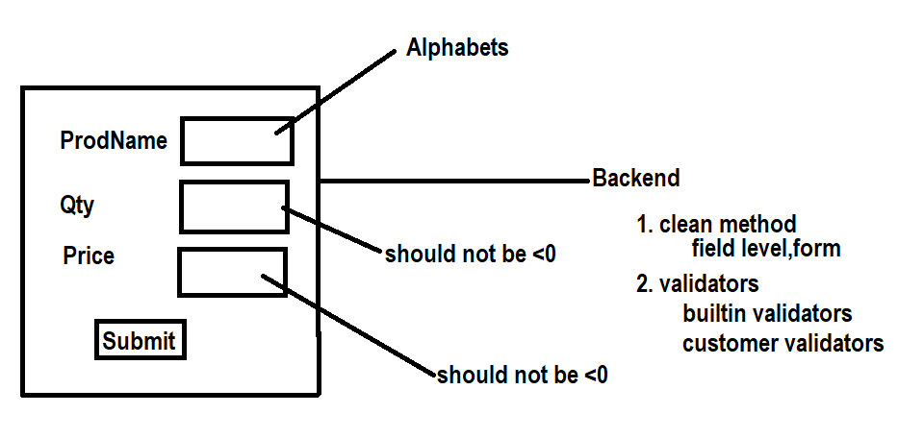

Forms.py
from django import forms

def alpha_validator(value):
if not value.isalpha():
raise forms.ValidationError("Contains Only Alphabets")
return value
def ng_validator(value):
if value<0:
raise forms.ValidationError("Value must be >=0")
return value

class ProductForm(forms.Form):
pname=forms.CharField(max_length=20,validators=[alpha_validator])
qty=forms.IntegerField(validators=[ng_validator])
price=forms.FloatField(validators=[ng_validator])

Views.py

from django.shortcuts import render
from app.forms import ProductForm
from django.http import HttpResponse
# Create your views here.
def prodview(request):
if request.method=="GET":
form=ProductForm()
response=render(request,"prodtemp.html",context={'form':form})
return response
else:
form=ProductForm(request.POST)
if form.is_valid():
response=HttpResponse("<h2>Valid Data</h2>")
return response
response=render(request,"prodtemp.html",context={'form':form})
return response

settings.py
INSTALLED_APPS = [
'django.contrib.admin',
'django.contrib.auth',
'django.contrib.contenttypes',
'django.contrib.sessions',
'django.contrib.messages',
'django.contrib.staticfiles',
'app'
]

TEMPLATES = [
{
'BACKEND': 'django.template.backends.django.DjangoTemplates',
'DIRS': [BASE_DIR/"templates"],
'APP_DIRS': True,

prodtemp.html
<!DOCTYPE html>
<html lang="en">
<head>
<meta charset="UTF-8">
<meta name="viewport" content="width=device-width, initial-scale=1.0">
<title>Document</title>
</head>
<body>
<form method="post">
{%csrf_token%}
<table border="2" width="100%">
{{form.as_table}}
<tr>
<td><input type="submit" value="submit"></td>
<td><input type="reset" value="reset"></td>
</tr>
</table>
</form>
</body>
</html>

Urls.py
from django.contrib import admin
from django.urls import path
from app.views import prodview

urlpatterns = [
path('admin/', admin.site.urls),
path('prodview/',prodview),
]

Views.py (inserting data within database table)
from django.shortcuts import render
from app.forms import ProductForm
from django.http import HttpResponse
from app.models import Product
# Create your views here.
def prodview(request):
if request.method=="GET":
form=ProductForm()
response=render(request,"prodtemp.html",context={'form':form})
return response
else:
form=ProductForm(request.POST)
if form.is_valid():
data=form.cleaned_data
prod=Product(pname=data['pname'],qty=data['qty'],price=data['price'])
prod.save()
response=render(request,"prodtemp.html",context={'form':form,'msg':'product created'})
return response
response=render(request,"prodtemp.html",context={'form':form})
return response

Model form
What is model form?
A form bind with model is called model form
A form created using fields of model is called model form

Advantage of model form
- Creating form field becomes easy because it create form fileds using fields defined inside model
- Perform crud operations are easy (insert, update, delete)

Basic steps for creating model form
- Create class by inheriting ModelForm class
- Inside class create another class (inner class)
class Meta:
model=model-class-name
fields=[‘field-name’,’field-name’,’field-name’]
“__all__”
exclude=[‘field-name’,’field-name’,field-name’]

forms.py
from django import forms
from app.models import UserRegister
class RegisterForm(forms.ModelForm):
class Meta:
model=UserRegister
fields='__all__'

models.py
from django.db import models

# Create your models here.

class UserRegister(models.Model):
name=models.CharField(max_length=20)
uname=models.CharField(max_length=15,primary_key=True)
password=models.CharField(max_length=15)
email=models.CharField(max_length=30)

views.py
from django.shortcuts import render
from app.forms import RegisterForm
# Create your views here.
def regview(request):
form=RegisterForm()
response=render(request,"register_temp.html",context={'form':form})
return response

settings.py
INSTALLED_APPS = [
'django.contrib.admin',
'django.contrib.auth',
'django.contrib.contenttypes',
'django.contrib.sessions',
'django.contrib.messages',
'django.contrib.staticfiles',
'app'
]

TEMPLATES = [
{
'BACKEND': 'django.template.backends.django.DjangoTemplates',
'DIRS': [BASE_DIR/"templates"],
'APP_DIRS': True,

Urls.py
from django.contrib import admin
from django.urls import path
from app.views import regview
urlpatterns = [
path('admin/', admin.site.urls),
path('regview/',regview),
]

